Exercises Set 1: String Concatenation

|  |  |
| --- | --- |
| Student Number | 2324915 |
| Name | Michael Shields |
| Student Email | mps4mpo[@bolton.ac.uk](mailto:xxx1crt@bolton.ac.uk) |

Please rename the file to include your student roll number.

Please submit the completed work in class at: <https://moodle.bolton.ac.uk/mod/turnitintooltwo/view.php?id=2469800>

# Exercise 1: Greeting User

Objective: Use f-strings to personalise a greeting.

Instructions:

1. Prompt the user for their name.

2. Print a greeting message that includes their name using an f-string.

Example Output:

Enter your name: Alice

Hello, Alice! Welcome to the world of Python programming.

## Program

print("Hello there stranger! What is your name? ")

username = input()

print(f"Hello {username}! Welcome to the world of Python.")

## Flowchart

## 

# Exercise 2: Age Calculator

Objective: Calculate the user's age based on their birth year.

Instructions:

1. Prompt the user for their birth year.

2. Calculate the current age (assume the current year is 2024).

3. Print a message with their age using an f-string.

Example Output:

Enter your birth year: 2000

You are 24 years old.

## Program

import datetime

user_date_of_birth = None

while ( user_date_of_birth == None):

print("Hello there user! I would like to calculate your age. Please can you tell me the YEAR you were born?")

try:

user_date_of_birth = int(input())

except ValueError:

print("You did not enter an integer!")

continue

if user_date_of_birth > datetime.datetime.now().year:

print("Please provide a YEAR that is less than or equal to the current year.")

user_date_of_birth = None

user_age = datetime.datetime.now().year - user_date_of_birth

print(f"You are {user_age} years old")

## Flowchart

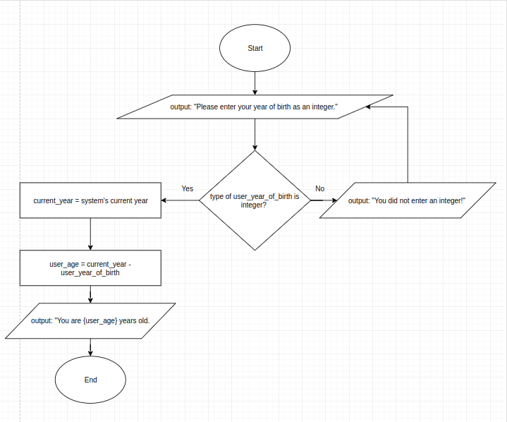

# 

# Exercise 3: Shopping List

Objective: Create a shopping list with item quantities.

Instructions:

1. Ask the user for three items they want to buy and their respective quantities.

2. Print a formatted shopping list using f-strings.

Example Output:

Enter item 1: Apples

Enter quantity for Apples: 5

Enter item 2: Bananas

Enter quantity for Bananas: 3

Enter item 3: Oranges

Enter quantity for Oranges: 2

Your shopping list:

- 5 Apples

- 3 Bananas

- 2 Oranges

## Program

shopping_list = {}

item_limit = 3

for item_count in range(item_limit):

print(f"Enter item {item_count + 1}: ")

item = input()

print(f"Enter quantity for {item}: ")

quantity = int(input())

shopping_list[ item ] = quantity

print("Your shopping list: ")

for item, quantity in shopping_list.items():

print(f"- {quantity} {item}")

## Flowchart

# 

# Exercise 4: Temperature Converter

Objective: Convert temperature from Celsius to Fahrenheit.

Instructions:

1. Prompt the user for a temperature in Celsius.

2. Convert it to Fahrenheit using the formula: \( F = C \times \frac{9}{5} + 32 \).

3. Print the result using an f-string.

Example Output:

Enter temperature in Celsius: 25

25 degrees Celsius is 77.0 degrees Fahrenheit.

## Program

celsius = None

while(celsius == None):

print("Enter a temperature in degrees Celsius: ")

try:

celsius = float(input())

except ValueError:

print("You did not enter a NUMERIC value. Please try again.")

celsius = None

fahrenheit = celsius * 9/5 + 32

print(f"{celsius} degrees Celsius is equal to {fahrenheit} degrees Fahrenheit.")

## Flowchart

# 

# Exercise 5: Full Name Formatter

Objective: Format and display a user's full name.

Instructions:

1. Prompt the user for their first name and last name.

2. Print their full name in a formatted message using an f-string.

Example Output:

Enter your first name: John

Enter your last name: Doe

Your full name is: John Doe

## Program

print("Enter your first name: ")

first_name = input()

print("Enter your last name: ")

last_name = input()

print(f"Your full name is: {first_name} {last_name}.")

## Flowchart

